from the recipe book of
Irene Prokopenko Birukow

Piroshki: (Poor man’s dinner)

FILLING:
3 lbs ground beef
1 ½ C mashed potato
½ onion, fine chopped
Salt & pepper to taste
¼ tsp each : 3 Sisters
- Ground cloves
- Nutmeg
- Allspice
DOUGH:
6 C flour
1 Tbsp sugar
½ C powdered milk
1Tbsp salt
3 C warm water
¼ C veg oil
1 C extra flour

YEAST:
2 pkg yeast
½ C warm water
1tsp sugar

UTENSILS:
1 pastry towel, damp
1 large mixing bowl
1 cup measure
2 cup measure
Measuring spoons

Heavy wooden mixing spoon
or a bread mixer
Rolling pin
2 cookie sheets- one lined with wax paper the other with paper towel
Plastic scraper (to clean counter off)
1 full bottle of Wesson veg oil
Wok ‘spider’
Heavy pot or iron skillet or Fry Daddy

MIX:
Yeast and sugar in a 2 cup measuring and add warm water. Stir gently and let sit for about 5-8 min until it rises.
COOK:
- Hamburger and onion, drain and let cool.
- boil 3 large potatoes, add ¼ C milk and mash add salt to taste, may refrigerate overnight

COMBINE: (3 sisters) spices into COLD meat, then add in mashed potatoes, mix together, set aside

MIX:
- All dry ingredients for dough together in a large mixing bowl.
- Then add liquids, mix by hand with a sturdy spoon or with a dough mixer.
- Last, add in raised yeast (it will be a bubbly brown)
- Put a few teaspoons of oil in the bowl and coat the dough with a little bit of oil, cover with plastic wrap.
- Let rise in a warm area, in the sun is best. DO NOT PUT IT IN THE OVEN
- You can either punch the dough down and let it rise a second time or use it after the first rise. The second rise makes a lighter fluffier dough.

I always wear a babushka for luck!
ROLL: take your extra cup of flour and sprinkle a little of it on either a pastry sheet or your clean counter top. Then take the dough out of the bowl and cut it in half,
roll both halves out into a long ‘snake’. About the thickness of a paper towel tube.
While working the dough make sure to cover with the damp pastry towel to keep from drying out.

Take one roll and cut the ‘snake’ into
2-3” sections.Take one section at a time, flatten it out a little and then roll it out until it is the size of your hand, but no larger. (should be slightly oblong) Hold this in your left hand.

Take your meat mixture and with a SOUP spoon get a nice scoop of it and place it in the middle of the dough in your hand. Then take the longest end and fold it over the meat until it meets the other long end (it now looks like a clam shell with the meat on the inside. Begin pinching the two edges together, If they do not want to seal together dab a little water on the inside edge to seal them. Then gently roll them back and forth in your hand with a bit of flour until the ‘seam’ is completely sealed. YOU DO NOT WANT THE INSIDES TO COME OUT IN THE FRYER.

Set the Piroshki on a cookie sheet lined with wax paper. Repeat the process until all the dough and meat is used up.

HINT: When I cut my dough, I count out how many I have and then I try to see how many ‘scoops’ of meat I can get lined up in my bowl to match the dough.

FRY: Get your heat started when you are about halfway through the second half of your dough. You can use either a FryDaddy, a DEEP iron skillet, or a heavy high-sided pot. (The higher the sides the less splattering of oil.) You will also need a set of long metal tongs and a Wok ‘spider’. I like the Wok tool because it is more gentle on the raw dough, I use the tongs to pull them out of the hot oil. At this time also preheat the oven to 250* Sometimes the piroshki may be undercooked after frying, but by putting it in the warm oven for 15-20 minutes after frying will ensure they are done. Keep covered in foil.

When you put the raw piroshki into the hot oil (340*) they will float to the top, let them cook for 4-5 minutes then turn them and let them cook for another 5 minutes. You may have to hold them with the tongs to ensure they don't flip over. If you have about 4-5 at a time it helps them to stay in place better. They should NOT be dark brown but a light golden color. As soon as they come out of the oil place on the 2nd cookie sheet lined with paper towel. Salt lightly. Yield: 30

HINT: break open the first one or two to see if they are well done in the middle, if they are slightly raw, put them in the oven and finish them by baking, then increase time in the oil.

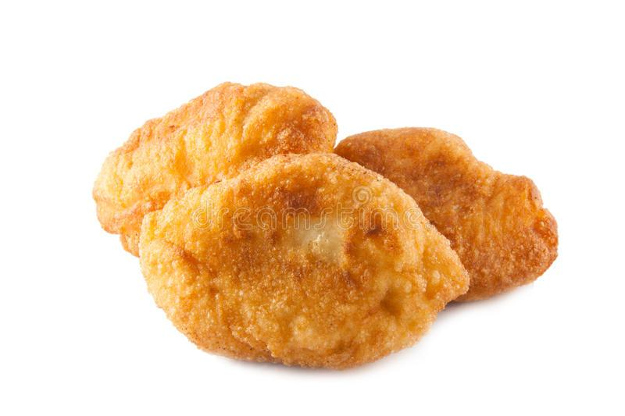
Dip in sour cream! Yum

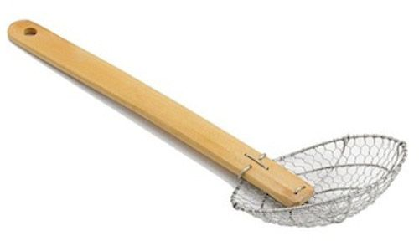
Wok Spider

